A REPORT
ON

“ The Stile Studio”
BY

Mr:-Rutuja Gondkar Roll No:18

Under Guidance of

Pooja Jagdish Thorat

Department of Computer Engineering
SHARADCHANDRA PAWAR COLLEGE OF ENGINEERING
At-Dumberwadi Post-Khamundi,Tal-Junner,Dist-Pune(410504)

SAVITRIBAI PHULE PUNE UNIVERSITY.PUNE
2023-24

ACKNOWLEDGEMNT

We would like to express our sincere gratitude to Dr. P. S. Gholap and other staff members for their constant support and guidance. We are extremely thankful for their encouragement and motivation throughout the project. Their valuable suggestions helped us in selecting the appropriate project topic. Without their guidance and inspiration, we would not have been able to choose and complete the right project successfully.

We would also like to express our heartfelt appreciation to all the individuals and teams involved in making our project, “The Style Studio”, a success. This project is basically a shopping website focused on traditional wear such as kurtis, kurtas, and other ethnic outfits. The dedication, hard work, and commitment of everyone involved have played an important role in completing this project effectively.

We extend our thanks to the development team for designing and implementing the website efficiently, ensuring a smooth and user-friendly shopping experience. Their creativity and technical skills helped bring the idea of an online traditional clothing store into reality.

We are also grateful to those who contributed ideas, feedback, and support during the development process. Their inputs helped us improve the quality and functionality of our website.

Finally, we would like to thank all well-wishers and supporters who encouraged us throughout this journey. Your support and trust inspired us to give our best and successfully complete this project.

Aim: The Style Studio (Online Traditional Shopping Website)

Objective:
The objective of The Style Studio can vary depending on the goals of the developers or organization behind it. However, some common objectives include:

• Enhancing Customer Convenience:
The primary objective of The Style Studio is to provide customers with an easy and convenient way to shop for traditional clothing such as kurtis, kurtas, and ethnic wear without visiting physical stores. This includes a user-friendly website interface and smooth browsing experience.

• Expanding Market Reach:
The platform aims to reach a wider audience by offering online shopping services. It allows customers from different locations to explore and purchase traditional outfits from the comfort of their homes.

• Improving Customer Experience:
The Style Studio focuses on providing a seamless and satisfying shopping experience by ensuring easy navigation, clear product details, high-quality images, secure payment options, and responsive customer support.

• Increasing Revenue:
The website serves as an additional sales channel for traditional clothing, helping to increase revenue by attracting more customers and boosting online purchases.

• Building Brand Loyalty:
The platform aims to develop long-term relationships with customers by offering quality products, reliable service, and a consistent shopping experience, encouraging repeat purchases.

• Adapting to Market Trends:
The Style Studio keeps up with the latest fashion trends in traditional wear and updates its collection accordingly to meet changing customer preferences.

• Leveraging Technology:
The website uses modern technologies such as online catalogs, secure payment gateways, and responsive design to enhance functionality and provide a smooth shopping experience across devices.

• These objectives may vary depending on the goals and priorities of the developers, as well as the needs and preferences of the target customers.

Procedure:

Creating a fully functional online shopping website like The Style Studio involves several steps, including designing the user interface, implementing product display logic, handling user interactions, and integrating a backend for data storage and user management. Below is the general procedure:
• Product Browsing:
Customers visit the website and browse through various categories such as kurtis, kurtas, and other traditional outfits using filters and search options.

• Product Selection:
Customers select their desired products, view details like size, color, price, and add items to their shopping cart.

• Order Placement:
Once the selection is complete, customers proceed to checkout, enter delivery details, and confirm their order.

• Order Processing:
After receiving the order, it is processed by the system and forwarded to the inventory or warehouse team for further action.

• Packaging:
The selected clothing items are carefully packed to ensure they remain safe, clean, and undamaged during transportation.

• Quality Check:
Before dispatch, the products undergo a quality check to ensure correct size, design, and quantity as per the order.

• Assigning Delivery Personnel:
The order is assigned to a delivery partner or courier service for shipment to the customer.

• Shipment & Tracking:
Customers are provided with tracking details so they can monitor the delivery status of their order in real time.

• Delivery:
The delivery partner delivers the package to the customer’s specified address.

• Payment:
Payment can be completed online through secure payment gateways (UPI, cards, net banking), or via cash on delivery (COD) options.

• Customer Support & Feedback:
After delivery, customers may provide feedback or ratings. Customer support assists in resolving issues like returns, exchanges, or queries.

• Inventory & Reporting:
The system updates stock levels automatically and generates reports related to sales, customer preferences, and order history.
This process may vary slightly depending on the specific features and business model of The Style Studio.

INTRODUCTION

The Style Studio is a convenient online shopping platform that allows customers to explore and purchase a variety of traditional clothing such as kurtis, kurtas, and other ethnic wear from the comfort of their homes or preferred location. This service has gained popularity due to its ease of use, especially in today’s fast-paced world where people prefer quick and hassle-free shopping options.
The introduction of online shopping platforms like The Style Studio has transformed the way people buy traditional outfits. Instead of visiting physical stores or spending time searching in crowded markets, customers can simply use a website or mobile device to browse collections, select products, and place orders within a few minutes.
The Style Studio offers a wide range of clothing options, including different styles, colors, sizes, and designs of traditional wear. Customers can view detailed product descriptions, compare options, customize their choices, and select suitable payment methods such as online payments, debit/credit cards, UPI, or cash on delivery.
One of the key advantages of The Style Studio is its convenience. Customers can shop anytime and from anywhere without the need to travel. This is especially beneficial for busy individuals, students, and working professionals who may not have time to visit physical stores.

Moreover, the platform leverages modern technology to improve the shopping experience by providing features such as easy navigation, secure payment systems, order tracking, notifications, and customer support. These features ensure a smooth and reliable shopping process.

In recent years, the demand for online shopping has increased due to factors such as digitalization, changing consumer behavior, and advancements in technology. As a result, platforms like The Style Studio provide a wide range of traditional clothing options to meet diverse customer preferences.
Overall, The Style Studio has become an important part of the online retail industry, offering convenience, accessibility, and variety to customers while creating new opportunities for businesses to expand their reach and increase sales.
.

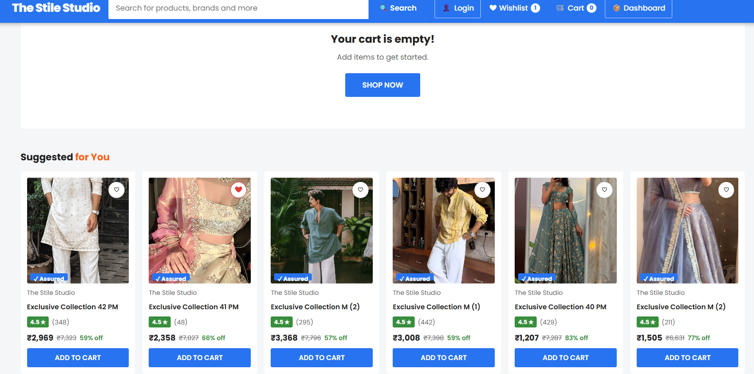
¬ Benefits of The Style Studio (Online Traditional Shopping System):

• Convenience:
The Style Studio provides great convenience to customers by allowing them to shop for traditional clothing such as kurtis and kurtas from the comfort of their homes, offices, or anywhere. This is especially helpful for busy individuals who prefer easy and quick shopping.

• Time-Saving:
Online shopping eliminates the need to visit physical stores, search through crowded markets, and wait in queues. Customers can quickly browse, select, and order products, saving valuable time.

• Expanded Accessibility:
The platform makes traditional clothing accessible to a wider audience, including customers from different cities and regions who may not have access to specific stores or collections.

• Increased Sales and Revenue:
For businesses, The Style Studio helps increase sales by reaching more customers online. It provides an additional platform for selling products and generating higher revenue.

• Competitive Advantage:
In today’s digital market, having an online shopping platform gives a strong advantage over traditional stores. Businesses offering easy and reliable online services can attract more customers and stand out from competitors.

• Customer Satisfaction:
By providing quality products, smooth navigation, secure payments, and timely delivery, The Style Studio enhances customer satisfaction and builds trust, encouraging repeat purchases.

• Flexibility:
Customers can shop anytime according to their convenience without being restricted by store timings. This flexibility makes online shopping more attractive.

• Wide Variety of Choices:
The platform offers a wide range of designs, styles, colors, and sizes in traditional wear, giving customers more options compared to limited physical store collections.

• Easy Comparison:
Customers can easily compare products, prices, and styles before making a purchase, helping them make better decisions.

• Weather and Mobility Benefits:
Online shopping is especially useful during bad weather or for people with mobility issues, as they can shop comfortably without leaving their homes.

Overall, The Style Studio offers numerous benefits such as convenience, time-saving, accessibility, increased business opportunities, customer satisfaction, flexibility, and a wide variety of choices. These advantages make it a highly useful and popular platform for both customers and sellers in the online shopping industry.

Source Code:

<!DOCTYPE html>
<html lang="en">

<head>
<meta charset="UTF-8" />
<meta name="viewport" content="width=device-width, initial-scale=1.0" />
<title>The Stile Studio – Fashion at Best Prices</title>
<script src="https://checkout.razorpay.com/v1/checkout.js"></script>
<link rel="preconnect" href="https://fonts.googleapis.com">
<link rel="preconnect" href="https://fonts.gstatic.com" crossorigin>
<link href="https://fonts.googleapis.com/css2?family=Poppins:wght@400;500;600;700;800&display=swap" rel="stylesheet">
<style>
* {
box-sizing: border-box;
margin: 0;
padding: 0
}

:root {
--blue: #2874f0;
--orange: #fb641b;
--green: #388e3c;
--yellow: #ffe119;
--gray: #f1f3f6;
--dark: #212121;
--mid: #666;
--light: #f5f6f8;
--red: #ff6161;
--purple: #7157d9;
}

body {
font-family: 'Poppins', sans-serif;
background: var(--light);
color: var(--dark);
font-size: 14px
}

/* ========= TOP BAR ========= */
.topbar {
position: sticky;
top: 0;
z-index: 100;
background: var(--blue);
color: #fff;
padding: 0 20px;
box-shadow: 0 2px 8px rgba(0, 0, 0, .3)
}

.topbar-inner {
display: flex;
align-items: center;
gap: 16px;
max-width: 1400px;
margin: 0 auto;
height: 56px
}

.brand {
font-size: 22px;
font-weight: 800;
cursor: pointer;
letter-spacing: -0.5px;
flex-shrink: 0;
color: #fff;
text-decoration: none
}

.brand span {
color: var(--yellow)
}

.search-wrap {
flex: 1;
max-width: 600px;
position: relative
}

.search-box {
display: flex;
background: #fff;
border-radius: 3px;
overflow: hidden
}

.search-box input {
flex: 1;
border: none;
outline: none;
padding: 10px 14px;
font-size: 14px;
font-family: inherit
}

.search-box button {
background: var(--blue);
border: none;
padding: 10px 18px;
cursor: pointer;
color: #fff;
font-weight: 600;
font-family: inherit;
font-size: 14px;
transition: background .2s
}

.search-box button:hover {
background: #1a5fd4
}

.suggest {
position: absolute;
top: 100%;
left: 0;
right: 56px;
background: #fff;
border: 1px solid #e0e0e0;
border-radius: 0 0 4px 4px;
box-shadow: 0 6px 16px rgba(0, 0, 0, .12);
z-index: 200;
max-height: 300px;
overflow-y: auto
}

.suggest.hidden {
display: none
}

.suggest-item {
display: flex;
align-items: center;
gap: 10px;
padding: 10px 14px;
cursor: pointer;
border-bottom: 1px solid #f5f5f5;
transition: background .15s
}

.suggest-item:hover {
background: #f5f5f5
}

.suggest-item img {
width: 36px;
height: 36px;
object-fit: cover;
border-radius: 3px;
background: #f0f0f0
}

.topbar-nav {
display: flex;
align-items: center;
gap: 4px;
flex-shrink: 0
}

.nav-btn {
background: transparent;
border: none;
color: #fff;
cursor: pointer;
font-family: inherit;
font-size: 14px;
font-weight: 500;
padding: 8px 12px;
border-radius: 3px;
display: flex;
align-items: center;
gap: 5px;
transition: background .2s;
text-decoration: none;
white-space: nowrap
}

.nav-btn:hover {
background: rgba(255, 255, 255, .15)
}

.nav-btn .count {
background: #fff;
color: var(--blue);
border-radius: 50%;
width: 18px;
height: 18px;
display: inline-flex;
align-items: center;
justify-content: center;
font-size: 11px;
font-weight: 700
}

.nav-btn.outline {
border: 1px solid rgba(255, 255, 255, .7)
}

/* ========= CATEGORY NAV ========= */
.cat-nav {
background: #fff;
box-shadow: 0 2px 4px rgba(0, 0, 0, .08);
overflow-x: auto;
scrollbar-width: none
}

.cat-nav::-webkit-scrollbar {
display: none
}

.cat-nav-inner {
display: flex;
justify-content: center;
gap: 0;
max-width: 1400px;
margin: 0 auto
}

.cat-item {
display: flex;
flex-direction: column;
align-items: center;
gap: 6px;
padding: 10px 20px;
cursor: pointer;
border-bottom: 3px solid transparent;
transition: all .2s;
white-space: nowrap;
font-size: 13px;
font-weight: 500;
color: var(--dark)
}

.cat-item:hover,
.cat-item.active {
color: var(--blue);
border-bottom-color: var(--blue)
}

.cat-item img {
width: 56px;
height: 56px;
object-fit: cover;
border-radius: 4px
}

/* ========= MAIN ========= */
#app {
max-width: 1400px;
margin: 0 auto;
padding: 16px
}

/* ========= BANNER CAROUSEL ========= */
.hero-section {
display: grid;
grid-template-columns: 210px 1fr 210px;
gap: 12px;
margin-bottom: 20px
}

.carousel {
position: relative;
border-radius: 4px;
overflow: hidden;
cursor: pointer
}

.slides {
display: flex;
transition: transform .5s ease
}

.slide {
min-width: 100%;
height: 270px;
background-size: cover;
background-position: center
}

.carousel-btn {
position: absolute;
top: 50%;
transform: translateY(-50%);
background: rgba(255, 255, 255, .9);
border: none;
cursor: pointer;
border-radius: 50%;
width: 32px;
height: 32px;
font-size: 18px;
display: flex;
align-items: center;
justify-content: center;
box-shadow: 0 2px 6px rgba(0, 0, 0, .2);
transition: background .2s;
z-index: 5
}

.carousel-btn:hover {
background: #fff
}

.carousel-btn.prev {
left: 8px
}

.carousel-btn.next {
right: 8px
}

.dots {
position: absolute;
bottom: 8px;
left: 50%;
transform: translateX(-50%);
display: flex;
gap: 5px
}

.dot {
width: 7px;
height: 7px;
border-radius: 50%;
background: rgba(255, 255, 255, .6);
cursor: pointer;
transition: background .2s
}

.dot.active {
background: #fff
}

.side-banner {
display: flex;
flex-direction: column;
gap: 12px
}

.side-card {
flex: 1;
border-radius: 4px;
overflow: hidden;
cursor: pointer;
position: relative;
min-height: 120px;
background-size: cover;
background-position: center
}

.side-card-label {
position: absolute;
bottom: 0;
left: 0;
right: 0;
background: linear-gradient(transparent, rgba(0, 0, 0, .7));
color: #fff;
padding: 8px 10px;
font-weight: 600;
font-size: 13px
}

/* ========= DEALS STRIP ========= */
.deals-section {
background: #fff;
border-radius: 4px;
padding: 16px;
margin-bottom: 20px;
box-shadow: 0 1px 3px rgba(0, 0, 0, .08)
}

.section-header {
display: flex;
align-items: center;
justify-content: space-between;
margin-bottom: 14px
}

.section-title {
font-size: 18px;
font-weight: 700
}

.section-title span {
color: var(--orange)
}

.view-all {
background: var(--blue);
color: #fff;
border: none;
padding: 8px 18px;
border-radius: 3px;
cursor: pointer;
font-family: inherit;
font-size: 13px;
font-weight: 600
}

.scrolling-wrapper {
display: flex;
overflow-x: auto;
gap: 14px;
padding-bottom: 8px;
scrollbar-width: thin
}

.scrolling-wrapper::-webkit-scrollbar {
height: 5px
}

.scrolling-wrapper::-webkit-scrollbar-thumb {
background: #ddd;
border-radius: 10px
}

.deal-card {
min-width: 140px;
text-align: center;
cursor: pointer;
padding: 8px;
border-radius: 4px;
transition: box-shadow .2s;
flex-shrink: 0
}

.deal-card:hover {
box-shadow: 0 4px 12px rgba(0, 0, 0, .1)
}

.deal-card img {
width: 120px;
height: 120px;
object-fit: cover;
border-radius: 3px;
margin-bottom: 8px;
background: #f5f5f5;
display: block;
margin: 0 auto 8px
}

.deal-card .deal-name {
font-size: 12px;
font-weight: 600;
margin-bottom: 3px;
white-space: nowrap;
overflow: hidden;
text-overflow: ellipsis
}

.deal-card .deal-off {
color: var(--green);
font-size: 12px;
font-weight: 700
}

.deal-card .deal-price {
font-size: 13px;
font-weight: 700;
color: var(--dark)
}

/* ========= PRODUCT GRID ========= */
.view-container {
display: flex;
gap: 16px
}

.sidebar {
width: 240px;
flex-shrink: 0;
background: #fff;
border-radius: 4px;
padding: 16px;
height: fit-content;
box-shadow: 0 1px 3px rgba(0, 0, 0, .08)
}

.sidebar h3 {
font-size: 16px;
font-weight: 700;
padding-bottom: 10px;
border-bottom: 1px solid #f0f0f0;
margin-bottom: 14px
}

.filter-section {
margin-bottom: 18px
}

.filter-title {
font-size: 12px;
font-weight: 700;
text-transform: uppercase;
color: var(--mid);
margin-bottom: 8px
}

.filter-option {
display: flex;
align-items: center;
gap: 8px;
padding: 4px 0;
cursor: pointer;
font-size: 13px
}

.filter-option input {
cursor: pointer;
accent-color: var(--blue)
}

.price-range {
display: flex;
gap: 8px;
align-items: center
}

.price-range input {
flex: 1;
padding: 6px 8px;
border: 1px solid #e0e0e0;
border-radius: 3px;
font-family: inherit;
font-size: 13px;
outline: none
}

.price-range input:focus {
border-color: var(--blue)
}

.sort-select {
width: 100%;
padding: 7px 10px;
border: 1px solid #e0e0e0;
border-radius: 3px;
font-family: inherit;
font-size: 13px;
outline: none;
cursor: pointer
}

.sort-select:focus {
border-color: var(--blue)
}

.content-area {
flex: 1;
min-width: 0
}

.grid {
display: grid;
grid-template-columns: repeat(auto-fill, minmax(190px, 1fr));
gap: 14px
}

.product {
background: #fff;
border-radius: 4px;
padding: 12px;
display: flex;
flex-direction: column;
gap: 8px;
position: relative;
transition: box-shadow .2s;
cursor: pointer
}

.product:hover {
box-shadow: 0 4px 16px rgba(0, 0, 0, .12)
}

.product-img-wrap {
position: relative;
width: 100%;
height: 200px;
overflow: hidden;
border-radius: 3px;
background: #f5f5f5
}

.product img {
width: 100%;
height: 100%;
object-fit: cover;
display: block;
transition: transform .3s
}

.product:hover img {
transform: scale(1.04)
}

.heart {
position: absolute;
top: 8px;
right: 8px;
background: #fff;
border: 1px solid #e0e0e0;
border-radius: 50%;
width: 30px;
height: 30px;
display: flex;
align-items: center;
justify-content: center;
cursor: pointer;
z-index: 2;
font-size: 15px;
transition: all .2s;
box-shadow: 0 1px 4px rgba(0, 0, 0, .1)
}

.heart.active {
color: #e53935;
border-color: #e53935
}

.brand-name {
font-size: 12px;
color: var(--mid)
}

.prod-name {
font-size: 13px;
font-weight: 600;
white-space: nowrap;
overflow: hidden;
text-overflow: ellipsis
}

.rating-pill {
background: var(--green);
color: #fff;
padding: 2px 6px;
border-radius: 3px;
font-size: 11px;
font-weight: 700;
display: inline-flex;
align-items: center;
gap: 2px
}

.rating-pill.low {
background: #f9a825
}

.rating-pill.very-low {
background: #e53935
}

.reviews {
font-size: 12px;
color: var(--mid)
}

.price-row {
display: flex;
align-items: center;
gap: 6px;
flex-wrap: wrap
}

.price {
font-size: 15px;
font-weight: 700
}

.mrp {
font-size: 12px;
color: var(--mid);
text-decoration: line-through
}

.discount {
font-size: 12px;
color: var(--green);
font-weight: 600
}

.assured {
height: 13px;
vertical-align: middle
}

.btn {
padding: 8px 12px;
border: none;
border-radius: 3px;
background: var(--blue);
color: #fff;
cursor: pointer;
font-weight: 600;
font-family: inherit;
font-size: 13px;
transition: all .2s;
width: 100%;
text-align: center
}

.btn:hover {
background: #1a5fd4
}

.btn.orange {
background: var(--orange)
}

.btn.orange:hover {
background: #e5550f
}

.btn.secondary {
background: #fff;
color: var(--dark);
border: 1px solid #d0d0d0
}

.btn.secondary:hover {
background: #f5f5f5
}

/* ========= PRODUCT DETAIL ========= */
.detail-wrap {
display: grid;
grid-template-columns: 420px 1fr;
gap: 20px
}

.gallery-section {
position: sticky;
top: 72px;
height: fit-content
}

.thumb-strip {
display: flex;
flex-direction: column;
gap: 8px;
margin-right: 12px
}

.thumb {
width: 60px;
height: 60px;
object-fit: cover;
border: 2px solid transparent;
border-radius: 3px;
cursor: pointer;
background: #f5f5f5
}

.thumb.active,
.thumb:hover {
border-color: var(--blue)
}

.main-img-wrap {
flex: 1;
background: #fff;
border-radius: 4px;
display: flex;
align-items: center;
justify-content: center;
padding: 20px;
height: 380px
}

.main-img {
max-width: 100%;
max-height: 340px;
object-fit: contain;
background: #fff
}

.gallery-inner {
display: flex;
gap: 10px;
background: #fff;
border-radius: 4px;
padding: 16px
}

.detail-actions {
display: grid;
grid-template-columns: 1fr 1fr;
gap: 12px;
margin-top: 12px
}

.detail-actions button {
padding: 14px;
font-size: 15px
}

.size-options {
display: flex;
gap: 8px;
flex-wrap: wrap;
margin-top: 6px
}

.size-btn {
padding: 6px 12px;
border: 1.5px solid #d0d0d0;
border-radius: 3px;
cursor: pointer;
font-family: inherit;
font-size: 13px;
background: #fff;
transition: all .2s
}

.size-btn:hover,
.size-btn.active {
border-color: var(--blue);
color: var(--blue);
background: #f0f5ff
}

.color-options {
display: flex;
gap: 8px;
flex-wrap: wrap;
margin-top: 6px
}

.color-circle {
width: 28px;
height: 28px;
border-radius: 50%;
cursor: pointer;
border: 2px solid transparent;
transition: all .2s
}

.color-circle:hover,
.color-circle.active {
border-color: var(--blue);
box-shadow: 0 0 0 2px rgba(40, 116, 240, .3)
}

.detail-tag {
background: #e8f4fd;
color: #0d47a1;
padding: 2px 8px;
border-radius: 3px;
font-size: 12px;
font-weight: 600;
display: inline-block;
margin-right: 6px
}

.offers-section {
background: #fff;
border-radius: 4px;
padding: 14px;
margin-top: 10px
}

.offer-item {
display: flex;
align-items: flex-start;
gap: 10px;
padding: 8px 0;
border-bottom: 1px dashed #f0f0f0;
font-size: 13px
}

.offer-item:last-child {
border: none
}

.offer-icon {
font-size: 16px;
margin-top: 1px
}

.spec-table {
width: 100%;
border-collapse: collapse;
font-size: 13px
}

.spec-table tr:nth-child(even) {
background: #fafafa
}

.spec-table td {
padding: 8px 12px;
border-bottom: 1px solid #f0f0f0
}

.spec-table td:first-child {
color: var(--mid);
width: 150px;
font-weight: 500
}

.review-card {
background: #fafafa;
border-radius: 4px;
padding: 14px;
margin-bottom: 12px
}

.review-header {
display: flex;
align-items: center;
gap: 10px;
margin-bottom: 8px
}

.reviewer {
font-weight: 600;
font-size: 13px
}

.review-text {
font-size: 13px;
color: var(--mid);
line-height: 1.5
}

.helpful-btn {
background: transparent;
border: 1px solid #d0d0d0;
border-radius: 3px;
padding: 4px 10px;
cursor: pointer;
font-size: 12px;
font-family: inherit;
margin-top: 8px
}

.pincode-check {
display: flex;
gap: 8px;
align-items: center;
margin-top: 8px
}

.pincode-check input {
padding: 8px 10px;
border: 1px solid #d0d0d0;
border-radius: 3px;
font-family: inherit;
font-size: 13px;
outline: none;
width: 140px
}

.pincode-check input:focus {
border-color: var(--blue)
}

.pincode-check button {
background: transparent;
border: none;
color: var(--blue);
font-weight: 700;
cursor: pointer;
font-family: inherit;
font-size: 13px
}

.delivery-info {
font-size: 13px;
color: var(--green);
margin-top: 8px;
font-weight: 500
}

/* ========= CART ========= */
.cart-wrap {
display: grid;
grid-template-columns: 1fr 340px;
gap: 16px;
align-items: start
}

.cart-items {
background: #fff;
border-radius: 4px;
overflow: hidden;
box-shadow: 0 1px 3px rgba(0, 0, 0, .08)
}

.cart-header {
padding: 14px 20px;
border-bottom: 1px solid #f0f0f0;
font-weight: 700;
font-size: 15px
}

.cart-item {
display: grid;
grid-template-columns: 100px 1fr;
gap: 16px;
padding: 20px;
border-bottom: 1px solid #f0f0f0
}

.cart-item:last-child {
border-bottom: none
}

.cart-item img {
width: 100px;
height: 100px;
object-fit: cover;
border-radius: 3px;
background: #f5f5f5
}

.cart-item-name {
font-size: 14px;
font-weight: 500;
margin-bottom: 4px
}

.cart-item-brand {
font-size: 12px;
color: var(--mid);
margin-bottom: 8px
}

.qty-controls {
display: flex;
align-items: center;
gap: 8px;
margin-bottom: 12px
}

.qty-btn {
width: 28px;
height: 28px;
border-radius: 50%;
border: 1px solid #d0d0d0;
background: #fff;
cursor: pointer;
font-size: 16px;
display: flex;
align-items: center;
justify-content: center;
font-weight: 600
}

.qty-btn:hover {
background: #f5f5f5
}

.qty-num {
font-size: 15px;
font-weight: 600;
min-width: 24px;
text-align: center
}

.cart-actions {
display: flex;
gap: 16px;
font-size: 13px;
font-weight: 600
}

.cart-action-btn {
background: none;
border: none;
cursor: pointer;
font-family: inherit;
font-size: 13px;
font-weight: 600;
color: var(--mid);
padding: 0;
transition: color .2s
}

.cart-action-btn:hover {
color: var(--dark)
}

.cart-action-btn.remove {
color: var(--red)
}

.price-summary {
background: #fff;
border-radius: 4px;
padding: 20px;
box-shadow: 0 1px 3px rgba(0, 0, 0, .08);
position: sticky;
top: 72px
}

.price-summary h3 {
font-size: 14px;
font-weight: 700;
color: var(--mid);
text-transform: uppercase;
letter-spacing: .5px;
padding-bottom: 12px;
border-bottom: 1px dashed #e0e0e0;
margin-bottom: 14px
}

.summary-row {
display: flex;
justify-content: space-between;
margin-bottom: 12px;
font-size: 14px
}

.summary-row.total {
font-size: 16px;
font-weight: 700;
padding-top: 12px;
border-top: 1px dashed #e0e0e0;
margin-top: 4px
}

.summary-row.saving {
color: var(--green);
font-weight: 600
}

.place-order-btn {
width: 100%;
padding: 14px;
background: var(--orange);
color: #fff;
border: none;
font-size: 15px;
font-weight: 700;
border-radius: 3px;
cursor: pointer;
font-family: inherit;
margin-top: 14px;
transition: background .2s
}

.place-order-btn:hover {
background: #e5550f
}

.security-badge {
text-align: center;
color: var(--mid);
font-size: 12px;
margin-top: 10px;
display: flex;
align-items: center;
justify-content: center;
gap: 5px
}

/* ========= CHECKOUT / PAYMENT ========= */
.checkout-wrap {
display: grid;
grid-template-columns: 1fr 340px;
gap: 16px;
align-items: start
}

.checkout-steps {
background: #fff;
border-radius: 4px;
box-shadow: 0 1px 3px rgba(0, 0, 0, .08);
overflow: hidden
}

.step-header {
background: var(--blue);
color: #fff;
padding: 14px 20px;
display: flex;
align-items: center;
gap: 12px;
font-weight: 700
}

.step-num {
width: 24px;
height: 24px;
background: rgba(255, 255, 255, .3);
border-radius: 50%;
display: flex;
align-items: center;
justify-content: center;
font-size: 13px;
font-weight: 700
}

.step-body {
padding: 20px
}

.form-row {
display: grid;
grid-template-columns: 1fr 1fr;
gap: 12px;
margin-bottom: 12px
}

.form-field {
display: flex;
flex-direction: column;
gap: 5px
}

.form-field.full {
grid-column: 1/-1
}

.form-label {
font-size: 12px;
font-weight: 600;
color: var(--mid)
}

.form-input {
padding: 10px 12px;
border: 1.5px solid #d0d0d0;
border-radius: 3px;
font-family: inherit;
font-size: 14px;
outline: none;
transition: border-color .2s
}

.form-input:focus {
border-color: var(--blue)
}

.pay-options {
display: flex;
flex-direction: column;
gap: 10px
}

.pay-opt {
display: flex;
align-items: center;
gap: 14px;
padding: 14px 16px;
border: 1.5px solid #e0e0e0;
border-radius: 4px;
cursor: pointer;
transition: all .2s
}

.pay-opt:hover {
border-color: var(--blue);
background: #f8fbff
}

.pay-opt.active {
border-color: var(--blue);
background: #f0f5ff
}

.pay-opt-icon {
font-size: 24px
}

.pay-opt-name {
font-weight: 600;
font-size: 14px
}

.pay-opt-sub {
font-size: 12px;
color: var(--mid)
}

.pay-opt-radio {
margin-left: auto
}

.proceed-btn {
width: 100%;
padding: 14px;
background: var(--orange);
color: #fff;
border: none;
font-size: 15px;
font-weight: 700;
border-radius: 3px;
cursor: pointer;
font-family: inherit;
margin-top: 14px
}

.upi-input {
display: flex;
gap: 8px;
margin-top: 10px
}

.upi-input input {
flex: 1;
padding: 9px 12px;
border: 1.5px solid #d0d0d0;
border-radius: 3px;
font-family: inherit;
font-size: 13px;
outline: none
}

.upi-input input:focus {
border-color: var(--blue)
}

.upi-input button {
padding: 9px 14px;
background: var(--blue);
color: #fff;
border: none;
border-radius: 3px;
cursor: pointer;
font-family: inherit;
font-size: 13px;
font-weight: 600
}

.card-form {
display: grid;
gap: 10px;
margin-top: 10px
}

.card-form input {
padding: 10px 12px;
border: 1.5px solid #d0d0d0;
border-radius: 3px;
font-family: inherit;
font-size: 13px;
outline: none
}

.card-form input:focus {
border-color: var(--blue)
}

.card-row {
display: grid;
grid-template-columns: 1fr 1fr;
gap: 10px
}

/* ========= PROCESSING OVERLAY ========= */
.processing-overlay {
position: fixed;
inset: 0;
background: rgba(255, 255, 255, .95);
display: flex;
flex-direction: column;
align-items: center;
justify-content: center;
z-index: 999
}

.spinner {
width: 48px;
height: 48px;
border: 4px solid #e0e0e0;
border-top-color: var(--blue);
border-radius: 50%;
animation: spin 1s linear infinite
}

@keyframes spin {
to {
transform: rotate(360deg)
}
}

.processing-overlay h2 {
margin-top: 20px;
font-size: 20px
}

.processing-overlay p {
color: var(--mid);
margin-top: 8px
}

.success-overlay {
position: fixed;
inset: 0;
background: rgba(255, 255, 255, .97);
display: flex;
flex-direction: column;
align-items: center;
justify-content: center;
z-index: 999;
text-align: center;
padding: 20px
}

.success-icon {
font-size: 80px;
animation: bounce .5s ease
}

@keyframes bounce {
0% {
transform: scale(0)
}

60% {
transform: scale(1.2)
}

100% {
transform: scale(1)
}
}

.success-overlay h2 {
font-size: 28px;
font-weight: 800;
color: var(--green);
margin-top: 16px
}

.success-overlay p {
color: var(--mid);
margin-top: 8px;
font-size: 16px;
max-width: 400px
}

.success-overlay .order-id {
background: #f0f5ff;
color: var(--blue);
padding: 8px 16px;
border-radius: 3px;
font-weight: 700;
font-size: 15px;
margin-top: 12px;
display: inline-block
}

.success-btn {
margin-top: 20px;
padding: 14px 40px;
background: var(--blue);
color: #fff;
border: none;
border-radius: 3px;
font-size: 15px;
font-weight: 700;
cursor: pointer;
font-family: inherit
}

/* ========= ORDERS ========= */
.orders-wrap {
display: flex;
flex-direction: column;
gap: 14px
}

.order-card {
background: #fff;
border-radius: 4px;
box-shadow: 0 1px 3px rgba(0, 0, 0, .08);
overflow: hidden
}

.order-header {
padding: 14px 20px;
border-bottom: 1px solid #f0f0f0;
display: flex;
align-items: center;
justify-content: space-between;
flex-wrap: wrap;
gap: 8px
}

.order-id {
font-size: 12px;
color: var(--mid)
}

.order-status {
font-weight: 700;
font-size: 14px
}

.order-status.paid {
color: var(--green)
}

.order-status.pending {
color: var(--orange)
}

.order-status.delivered {
color: var(--blue)
}

.order-items {
padding: 14px 20px;
display: grid;
grid-template-columns: repeat(auto-fill, minmax(200px, 1fr));
gap: 12px
}

.order-item {
display: flex;
gap: 12px;
align-items: center
}

.order-item img {
width: 60px;
height: 60px;
object-fit: cover;
border-radius: 3px;
background: #f5f5f5;
flex-shrink: 0
}

.order-item-info {
flex: 1;
min-width: 0
}

.order-item-name {
font-size: 13px;
font-weight: 600;
white-space: nowrap;
overflow: hidden;
text-overflow: ellipsis
}

.order-item-qty {
font-size: 12px;
color: var(--mid)
}

.order-item-price {
font-size: 14px;
font-weight: 700
}

.order-footer {
padding: 12px 20px;
background: #fafafa;
border-top: 1px solid #f0f0f0;
display: flex;
align-items: center;
justify-content: space-between
}

.order-track {
display: flex;
gap: 0;
align-items: center;
padding: 14px 20px;
overflow-x: auto
}

.track-step {
display: flex;
flex-direction: column;
align-items: center;
flex: 1;
min-width: 90px
}

.track-dot {
width: 14px;
height: 14px;
border-radius: 50%;
background: #e0e0e0;
z-index: 1;
position: relative
}

.track-dot.done {
background: var(--green)
}

.track-dot.active {
background: var(--blue);
box-shadow: 0 0 0 4px rgba(40, 116, 240, .2)
}

.track-line {
height: 3px;
flex: 1;
background: #e0e0e0;
margin-bottom: 24px
}

.track-line.done {
background: var(--green)
}

.track-label {
font-size: 11px;
color: var(--mid);
margin-top: 6px;
text-align: center
}

.track-label.done {
color: var(--green);
font-weight: 600
}

.track-label.active {
color: var(--blue);
font-weight: 700
}

.track-row {
display: flex;
align-items: center;
padding: 14px 20px
}

/* ========= WISHLIST ========= */
/* uses .grid and .product */

/* ========= DASHBOARD ========= */
.dashboard-wrap {
display: flex;
flex-direction: column;
gap: 20px
}

.dashboard-stats {
display: grid;
grid-template-columns: repeat(auto-fit, minmax(180px, 1fr));
gap: 14px
}

.stat-card {
background: #fff;
border-radius: 4px;
padding: 16px;
box-shadow: 0 1px 3px rgba(0, 0, 0, .08);
text-align: center
}

.stat-num {
font-size: 32px;
font-weight: 800;
color: var(--blue)
}

.stat-label {
color: var(--mid);
font-size: 13px;
margin-top: 4px
}

.add-product-form {
background: #fff;
border-radius: 4px;
padding: 20px;
box-shadow: 0 1px 3px rgba(0, 0, 0, .08)
}

.add-product-form h3 {
margin-bottom: 14px;
font-size: 16px
}

.add-form-grid {
display: grid;
grid-template-columns: repeat(auto-fill, minmax(180px, 1fr));
gap: 10px
}

.add-input {
padding: 9px 12px;
border: 1.5px solid #e0e0e0;
border-radius: 3px;
font-family: inherit;
font-size: 13px;
outline: none
}

.add-input:focus {
border-color: var(--blue)
}

.add-input.full {
grid-column: 1/-1
}

/* ========= MODAL / TOAST ========= */
.modal {
position: fixed;
inset: 0;
background: rgba(0, 0, 0, .5);
display: flex;
align-items: center;
justify-content: center;
z-index: 500
}

.modal.hidden {
display: none
}

.modal-content {
background: #fff;
border-radius: 8px;
padding: 28px;
min-width: 320px;
max-width: 400px;
width: 90%
}

.modal-content h2 {
font-size: 20px;
font-weight: 700;
margin-bottom: 6px
}

.modal-content p {
color: var(--mid);
font-size: 13px;
margin-bottom: 18px
}

.modal-input {
width: 100%;
padding: 11px 14px;
border: 1.5px solid #d0d0d0;
border-radius: 4px;
font-family: inherit;
font-size: 14px;
outline: none;
margin-bottom: 12px
}

.modal-input:focus {
border-color: var(--blue)
}

.modal-btn {
width: 100%;
padding: 12px;
border: none;
border-radius: 4px;
background: var(--blue);
color: #fff;
font-size: 15px;
font-weight: 700;
cursor: pointer;
font-family: inherit
}

.modal-close {
background: none;
border: none;
color: var(--mid);
cursor: pointer;
font-size: 14px;
margin-top: 10px;
width: 100%;
font-family: inherit;
padding: 6px
}

.toast {
position: fixed;
bottom: 32px;
left: 50%;
transform: translateX(-50%);
background: var(--dark);
color: #fff;
padding: 12px 24px;
border-radius: 4px;
z-index: 999;
box-shadow: 0 4px 16px rgba(0, 0, 0, .3);
font-size: 14px;
font-weight: 500;
transition: opacity .3s;
white-space: nowrap
}

.toast.hidden {
opacity: 0;
pointer-events: none
}

/* ========= EMPTY STATE ========= */
.empty-state {
text-align: center;
padding: 60px 20px;
background: #fff;
border-radius: 4px
}

.empty-state .e-icon {
font-size: 64px;
margin-bottom: 16px
}

.empty-state h2 {
font-size: 20px;
font-weight: 700;
margin-bottom: 8px
}
.empty-state p {
color: var(--mid);
margin-bottom: 20px
}
.empty-state .btn {
width: auto;
display: inline-block;
padding: 12px 32px;
font-size: 14px
} function goSlide(n) { idx = n;
})();
</script>
</body></html>

Output:-
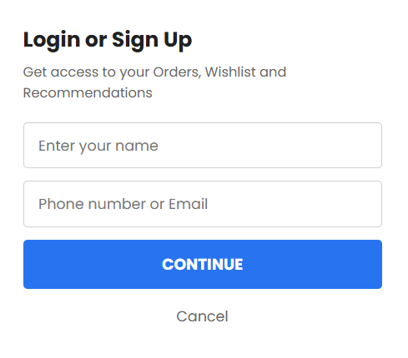

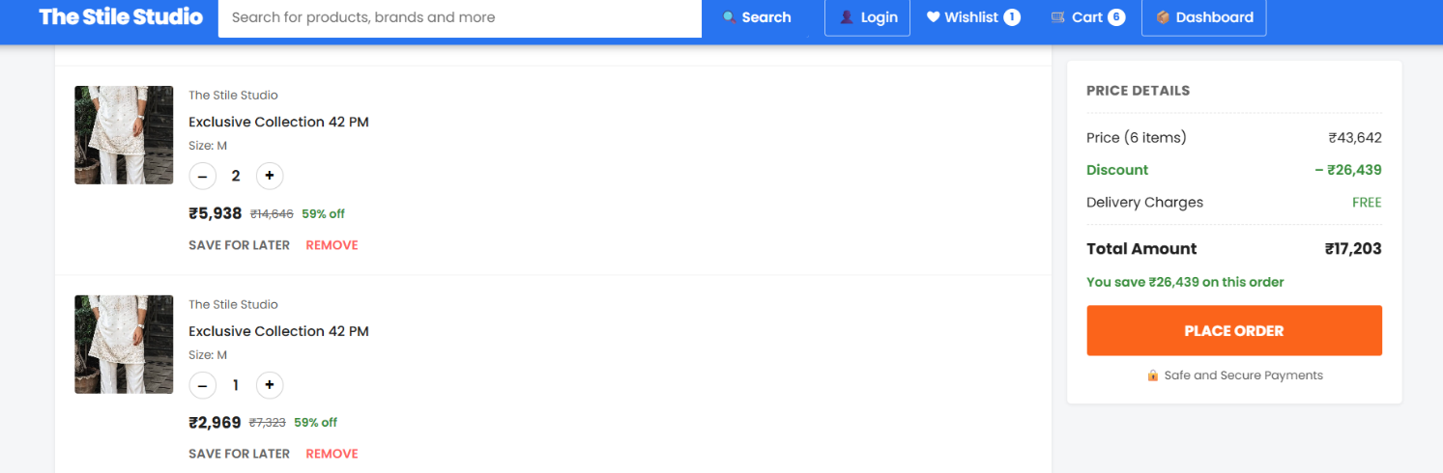

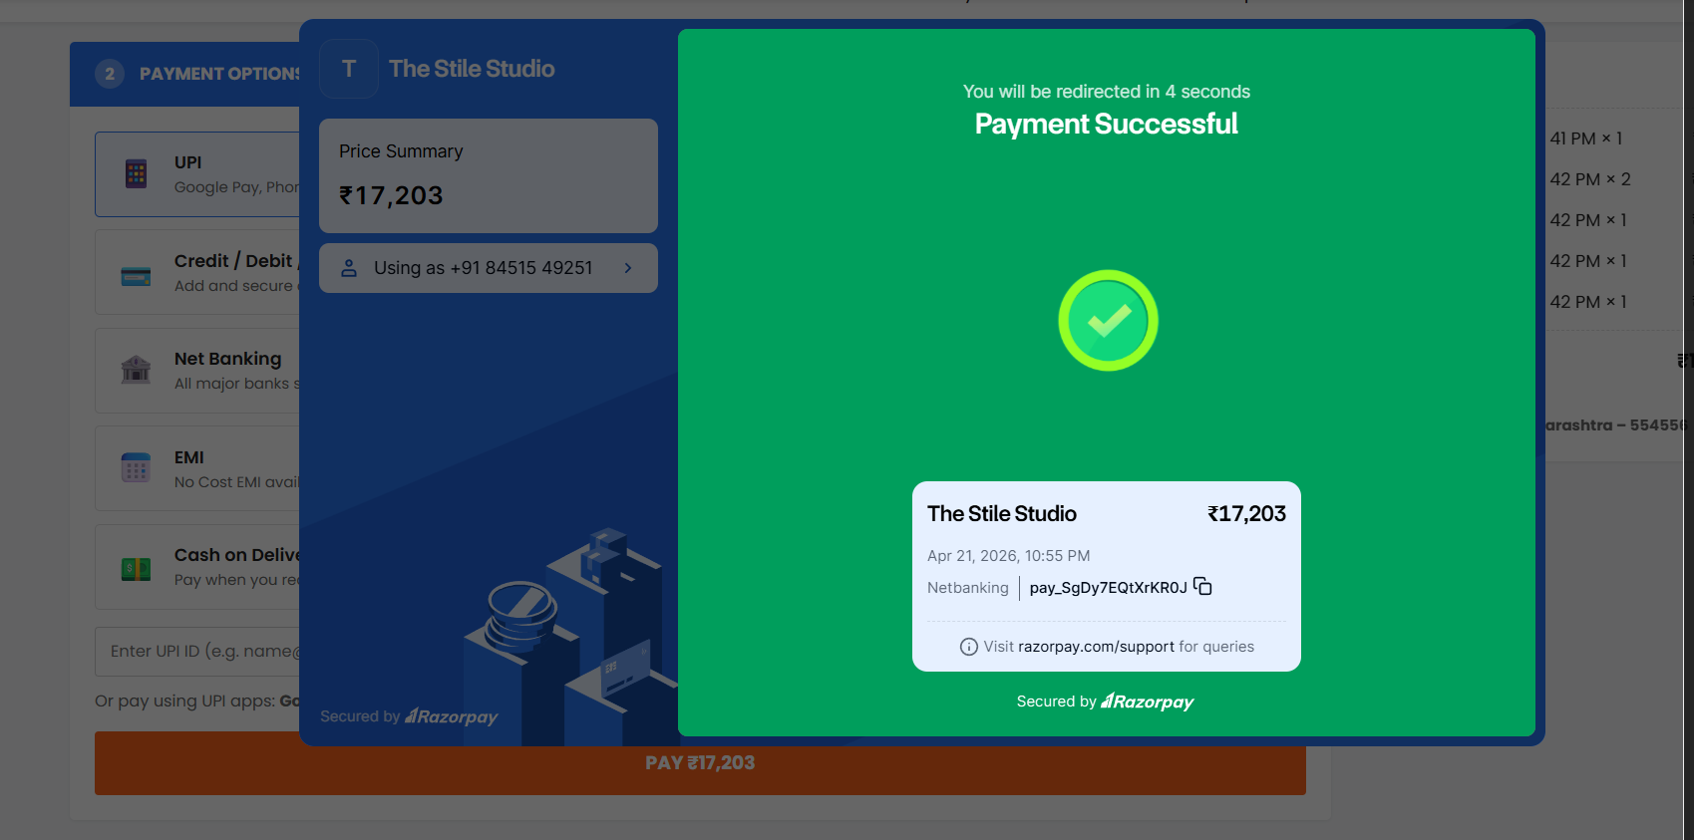

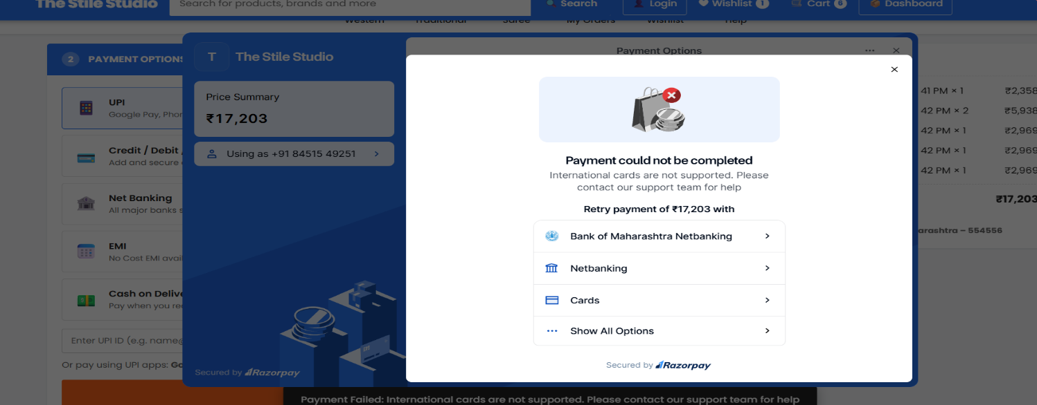



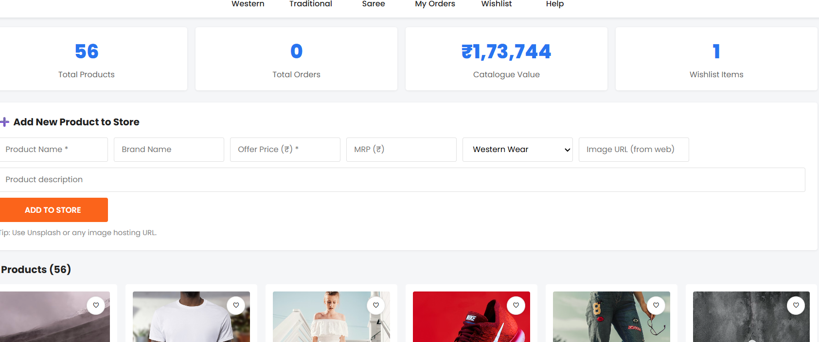

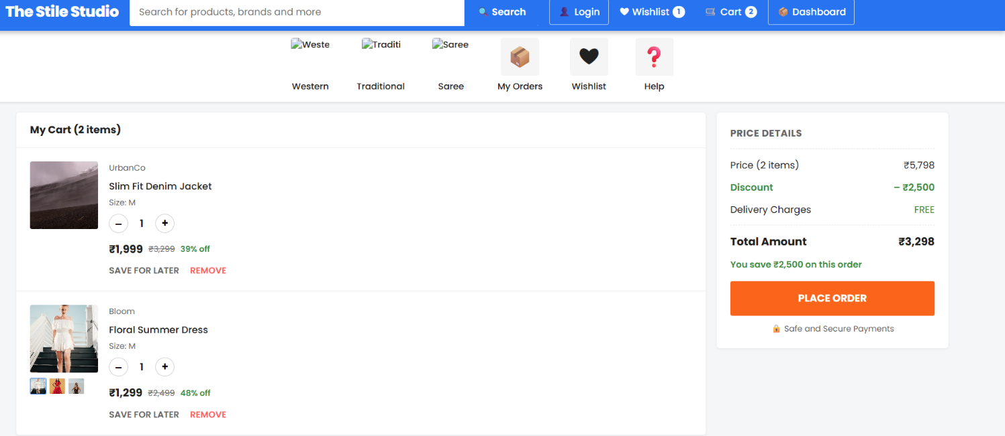

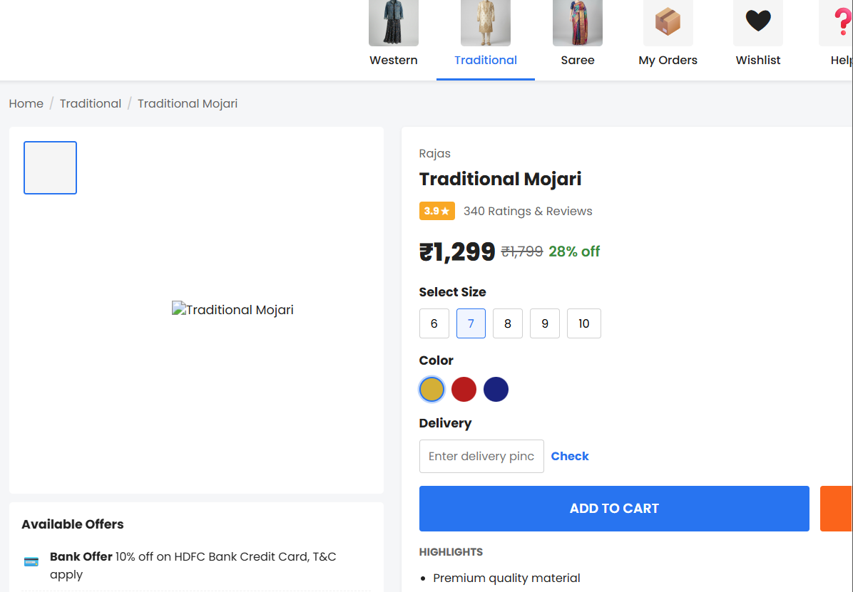
FUTURE SCOPE

The future scope for The Style Studio is highly promising, with several trends and technological advancements expected to enhance the online shopping experience:

• Drone Delivery:
With advancements in drone technology, The Style Studio may adopt drone-based delivery systems for faster and more efficient shipping, especially in urban areas where traffic congestion is a
challenge.

• Autonomous Delivery Systems:
Self-driving delivery vehicles and robots can be used for delivering clothing orders, reducing delivery time and operational costs while improving efficiency.

• Hyperlocal Delivery Networks:
The platform may develop localized warehouses or distribution centers to ensure quicker deliveries and better inventory management for specific regions.

• Integration with Smart Technology:
The Style Studio can integrate with smart devices such as voice assistants, smartwatches, and IoT devices, allowing customers to browse and order traditional outfits more conveniently.

• Personalized Recommendations:
Using Artificial Intelligence (AI) and data analytics, the website can provide personalized clothing suggestions based on customer preferences, past purchases, and fashion trends.

• Sustainability and Eco-Friendly Practices:
With increasing awareness about sustainability, The Style Studio may adopt eco-friendly packaging, promote sustainable fabrics, and support ethical fashion practices.

• Virtual Try-On Technology:
Future advancements may include virtual fitting rooms using augmented reality (AR), allowing customers to try on kurtis, kurtas, and other outfits digitally before purchasing.

• Expansion of Product Range:
The platform can expand its collection to include more traditional wear categories such as sarees, lehengas, accessories, and footwear to attract a wider customer base.

• Contactless Delivery and Payments:
Contactless delivery and secure online payment methods will continue to grow, ensuring safety, convenience, and a smooth shopping experience.

• Subscription-Based Models:
The Style Studio may introduce subscription services where customers receive curated traditional outfits regularly based on their style preferences at discounted prices.
Overall, The Style Studio has a bright future with continuous improvements in technology, customer experience, and product offerings. These advancements will help the platform grow, attract more customers, and stay competitive in the online fashion industry.

.

CONCLUSION

In conclusion, the future of The Style Studio holds great potential, driven by advancements in technology, evolving customer preferences, and the growing demand for convenient online shopping. With the integration of modern technologies such as artificial intelligence, virtual try-on features, and smart device compatibility, the online shopping experience for traditional wear is continuously improving.
Additionally, there is an increasing focus on personalization, sustainability, and contactless services, reflecting current market trends. Features such as personalized recommendations, eco-friendly practices, and secure digital payments contribute to enhancing customer satisfaction and trust.
The expansion of product categories, introduction of subscription-based models, and improved delivery systems further strengthen the growth opportunities of The Style Studio. As more customers shift towards online platforms for purchasing traditional outfits, such websites are becoming an essential part of the fashion industry.
With continuous innovation, efficiency, and a strong focus on customer experience, The Style Studio is well-positioned to grow and succeed in the competitive online retail market. The future of online traditional shopping platforms is bright and full of opportunities.

References:
¬ Industry Reports: Reports from market research firms such as Statista, Euromonitor International, and IBISWorld provide valuable insights into trends and forecasts for the online shopping and fashion industry.
¬ Tech News Websites: Websites like TechCrunch, Wired, and Engadget frequently cover developments in e-commerce technology, AI, and online retail innovations.
¬ Academic Journals: Journals in fields like e-commerce, fashion technology, and information systems publish research on topics related to online shopping platforms and their future scope.
- https://github.com/nsevindi87/multipage-website/tree/main/image
- http://www.javaworld.com/javaworld/jw-01-1998/jw-01-credentialreveiw.html
- http://jdbc-tutorial.com
- https://www.tutorialspoint.com/java

